|  |  |
| --- | --- |
| Project Leader: | Vijaya Vamsikrishna Marrisetty |
| Team Members: | Rakesh Videm, Venkat Kranthi Reddy Madhire, Ajay Kumar Reddy Addula |
| Mentors | Lee, Yugyung, Wahlman, Maude S |

##### **Think you know history?**

Version 4.4

March 21, 2014



History Trivia

Project First Increment

# History Trivia

History is the study of the past, specifically how it relates to humans. It is an umbrella term that relates to past events as well as the discovery, collection, organization, and presentation of information about these events.

## Objective

History trivia is mobile game application which is not just a game but also u can challenge the other players in the multiplayer mode and collect different artifacts for each level. There are many quiz applications present in the web, but you can’t access them directly on your mobile web browser. User face compatibility issues while using them on mobile browser. Our objective is to overcome these issue and build a cool user interface application.

## Detail Design of service

**User Stories /Use Case**

Till now we have gathered the required information for Dr. Wahlman, Maude S about the images to be inserted in the quiz questions. Now in the present phase we are designing the database, home page and login page of the quiz application. The task has been equally distributed among the team where we are going in several steps like:

* Creation of UML sequence and class diagram to the present phase.
* Creation of backend database.
* Creation of front end view of the application.
* Preparation of test cases for phase-1.
* Reviewing the work done for the phase.

**Sequence diagram**

In this sequence diagram we are explaining about the phase-1 development of front and back end scenario. It clearly explains about the student accessing the application and login validations by the database in the backend. Only the registered students (Students present in database) will be able to login the quiz.



**Class diagram**

In this Class diagram we are explaining about the phase-1 development of front and back end scenario. It describes about relation between web service, database and user. The Quiz Master and web service are inherited from the data base. The data base will be updated with all the student information like user ID, password, quiz marks and grades.



**Design of Unit test case**

We have designed few test cases for the user login page till which we have implemented.

Test cases:

* Student should be able to launch the web application.
* Student should be able to view the home page of web application.
* Student should be able to click on “Login” Button.
  + Student should be able to view the login page.
  + Student should be able to enter the login details.
  + Student should be able to login.
  + (Negative scenario) Student is not able to login. (Only if student is not registered.)
* Student should be able to click on Register Button.
  + Student should be able to enter the user name.
  + Student should be able to enter the password.
  + Error message if password is less than 6 characters.
  + Student should be able to register and navigated to home page.

## Report

Manual testing for the application has been done and screen shots have been updated accordingly.

This is the welcome page :

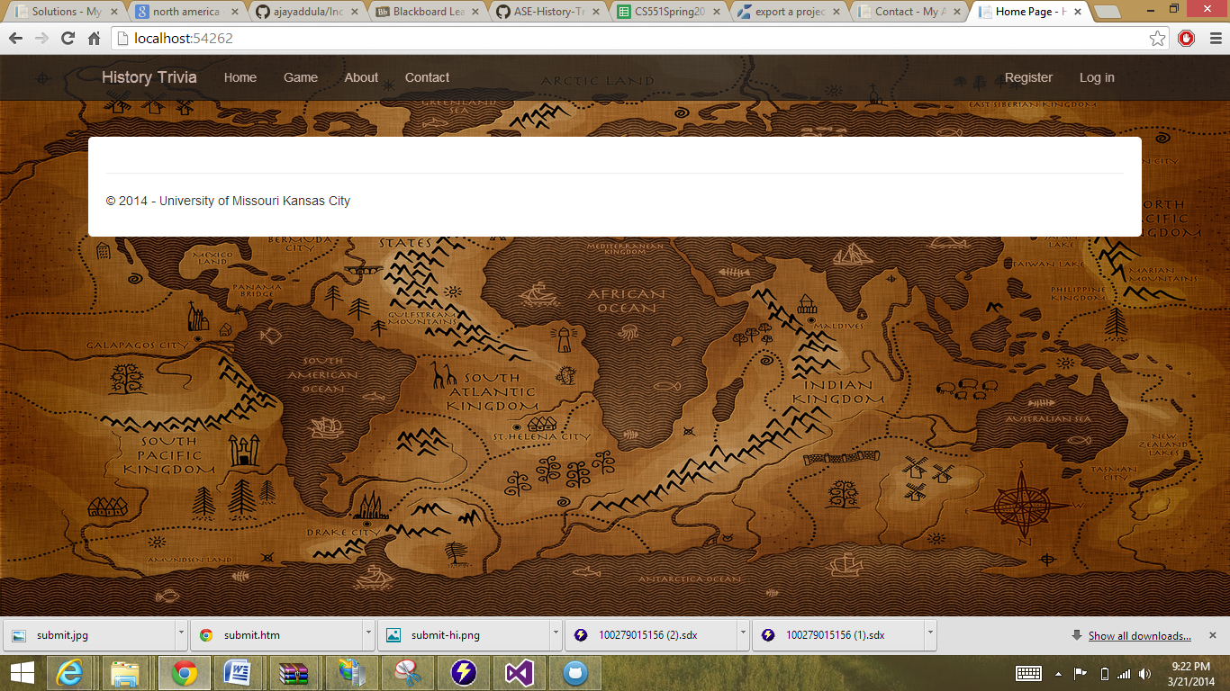

This is the Register page which shows error when incorrect password given :

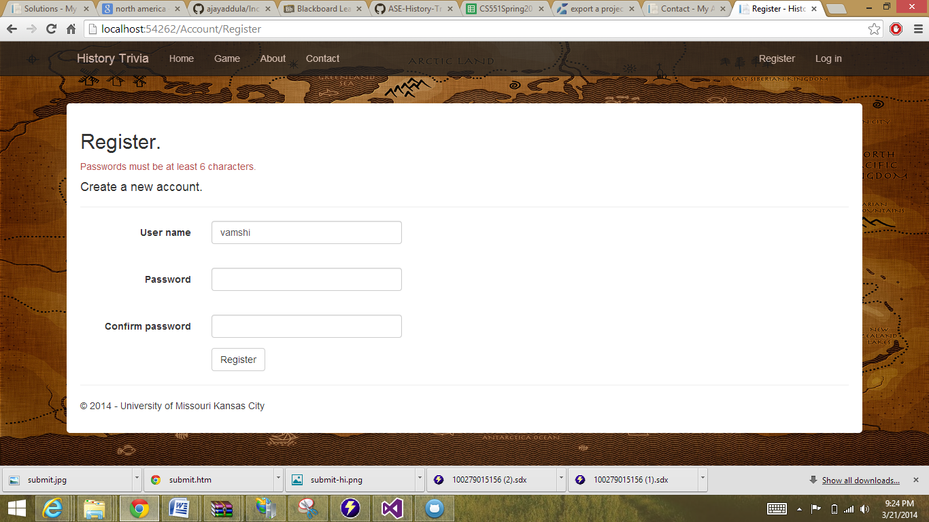

This is the Register success page :

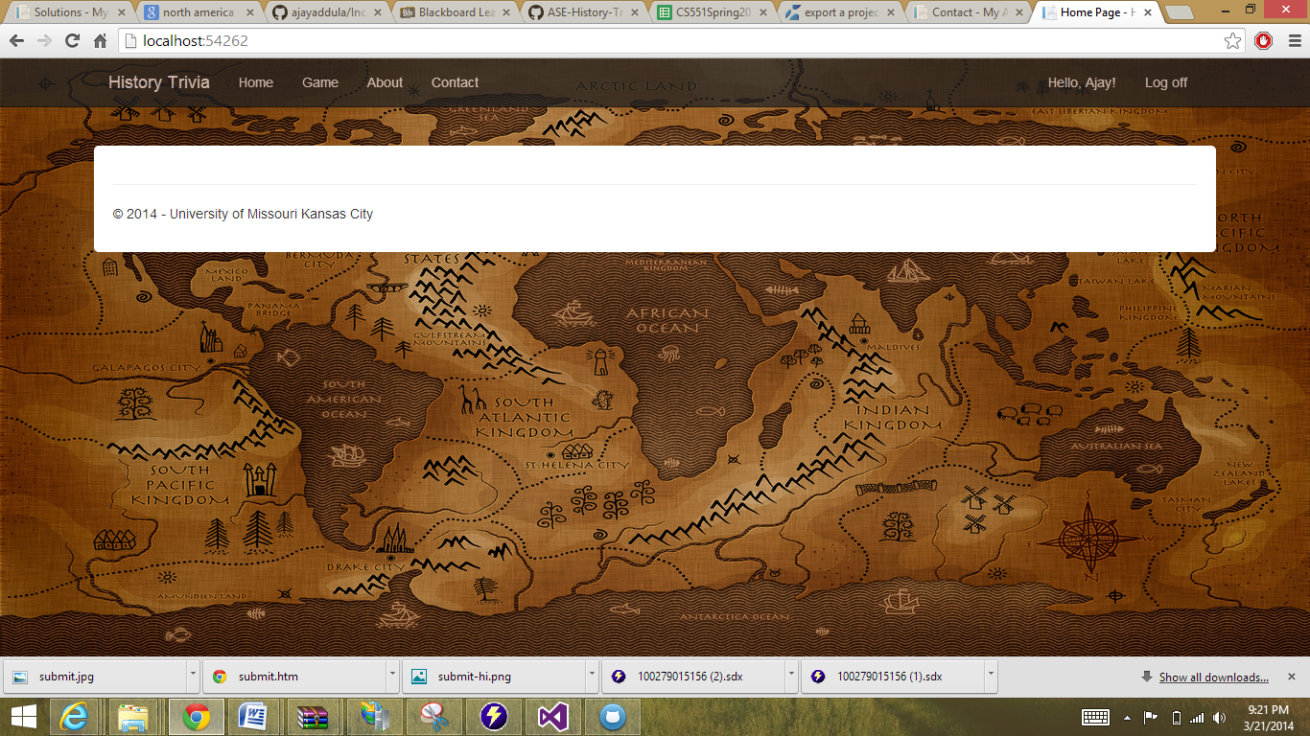

This page shows the Manage Account of User :

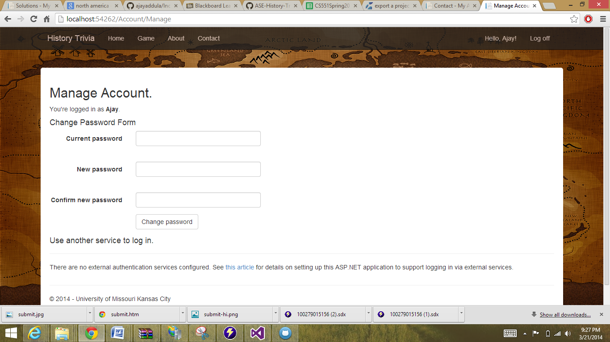

This is the Game page:

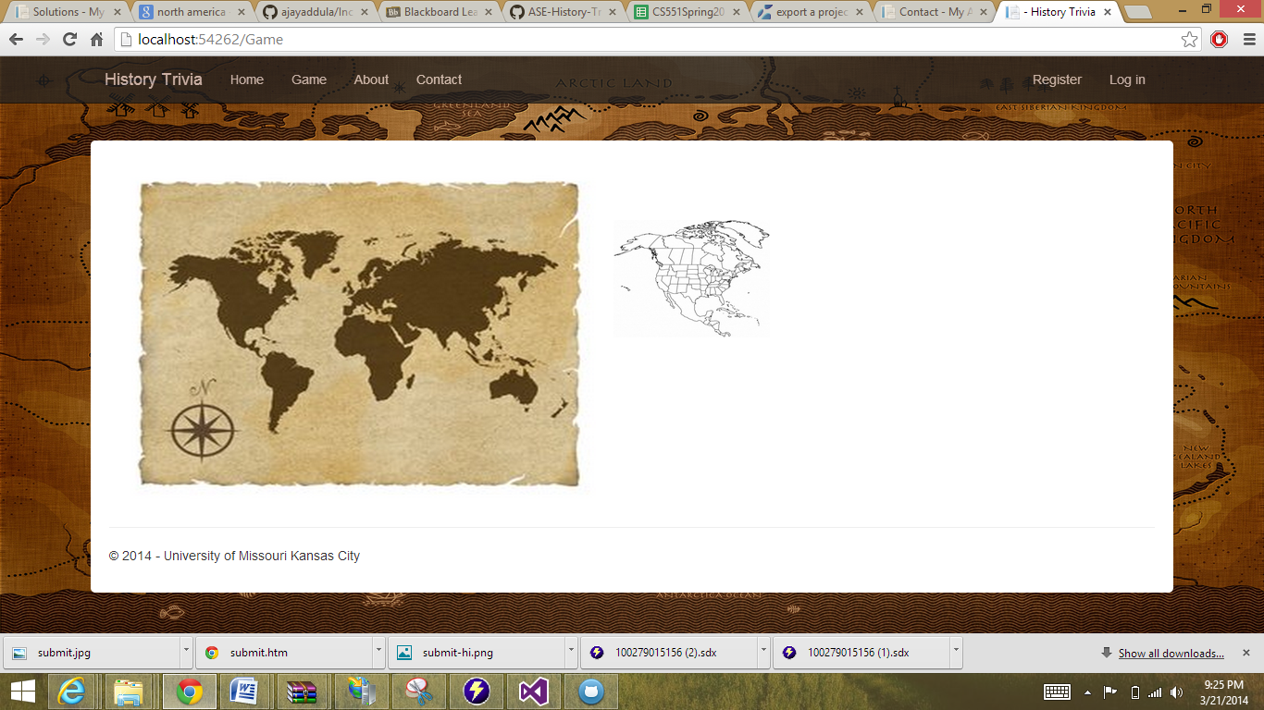

This page is generated when we select North America:

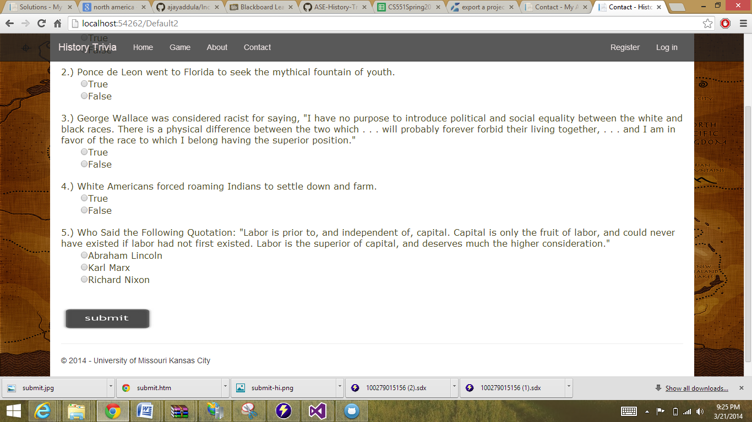

We navigate to this page when we click submit:

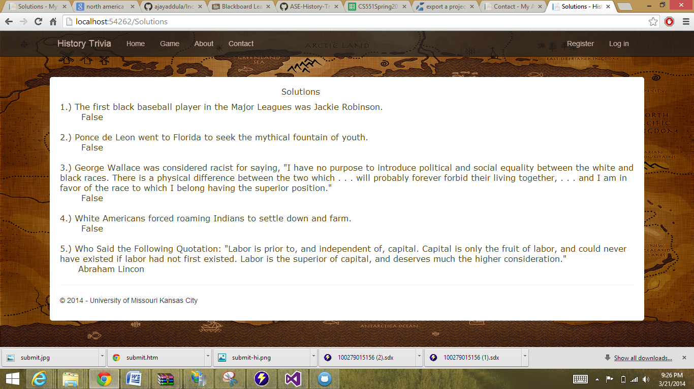

**DATabase**

**Database Tool:** Access 2007

**Student Table:**This table has all the details of the students from all Majors of UMKC viz Student Id, Student Name and Major.

*Primary Key:* Student Id.

Student Id is the basic requirement to login to the application. As discussed already our project is confined for UMKC, only students with valid student Id will be able to login to the application.

Please see the screen shot of the student table.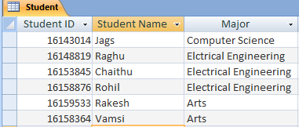

**Country Table:**This table has all the names of all the countries with their country code.

*Primary Key:* Country Id.

Country table is used to select the appropriate country to which the student play the quiz for.

Please see the screen shot of the Country table.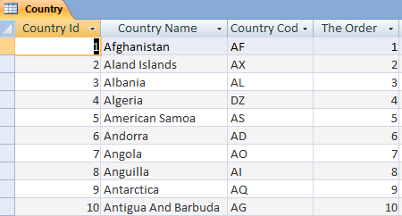

**Access Database File:**

**This file is only for testing purpose, the main database will be generated using MS SQL server14once all the quiz information is received from the art department.**



## Project Management

Distribution of Work:

The work has been divided among the team using Scrum do and updated on every step.

Scrum Do: <http://www.scrumdo.com/projects/project/quest1/iteration/94673>

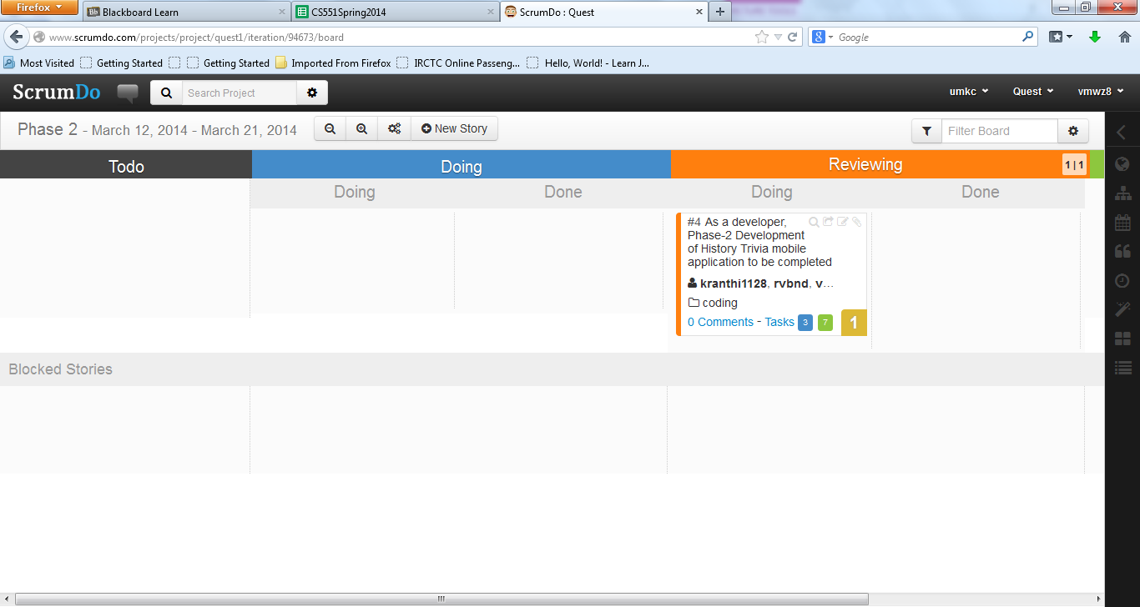

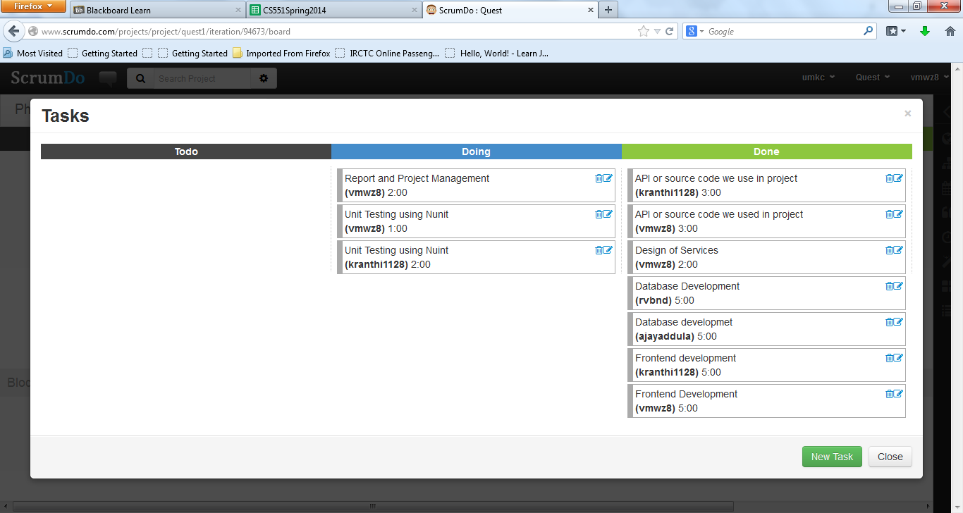

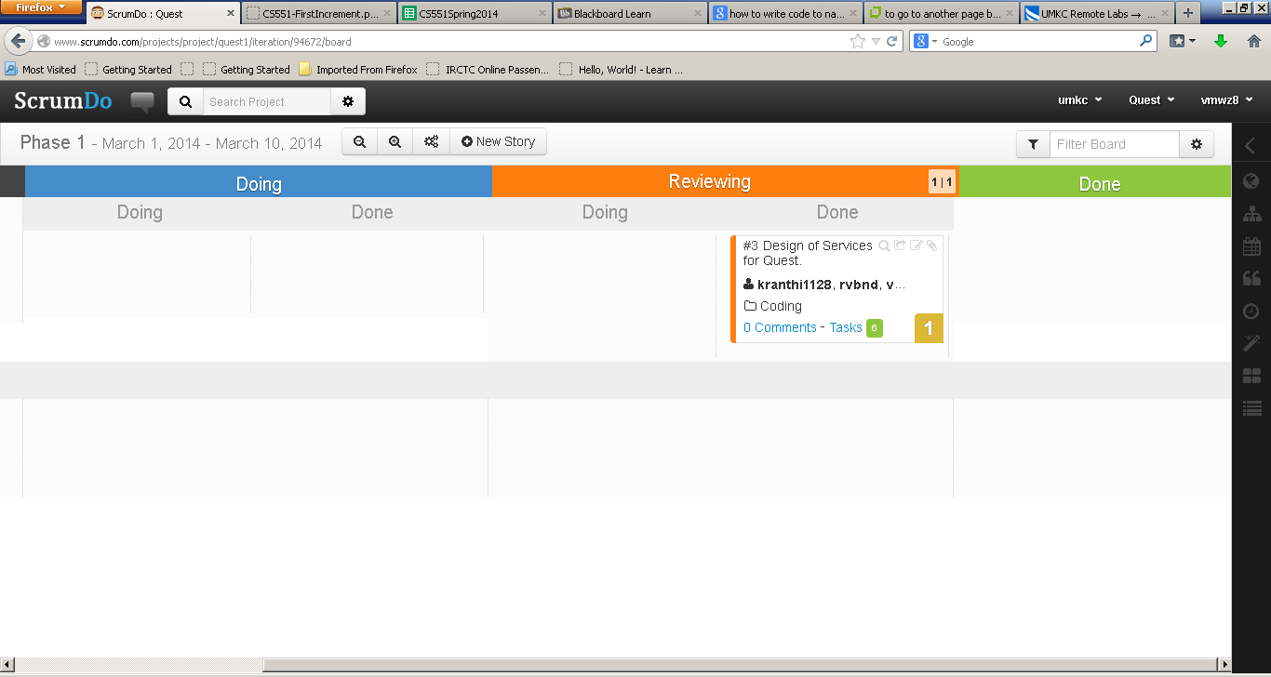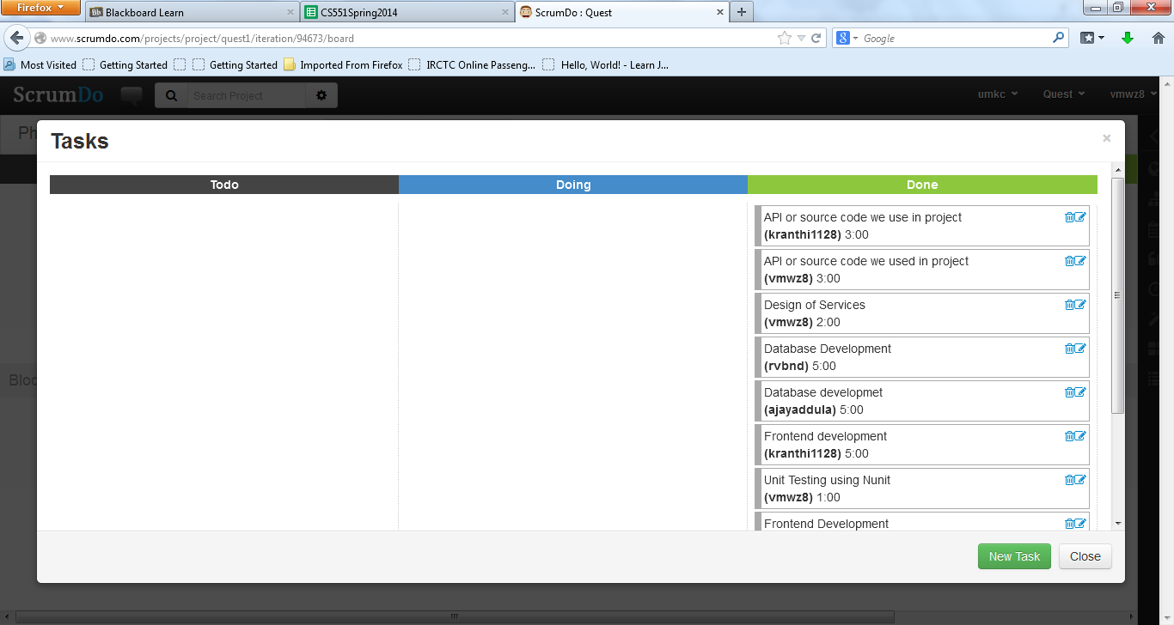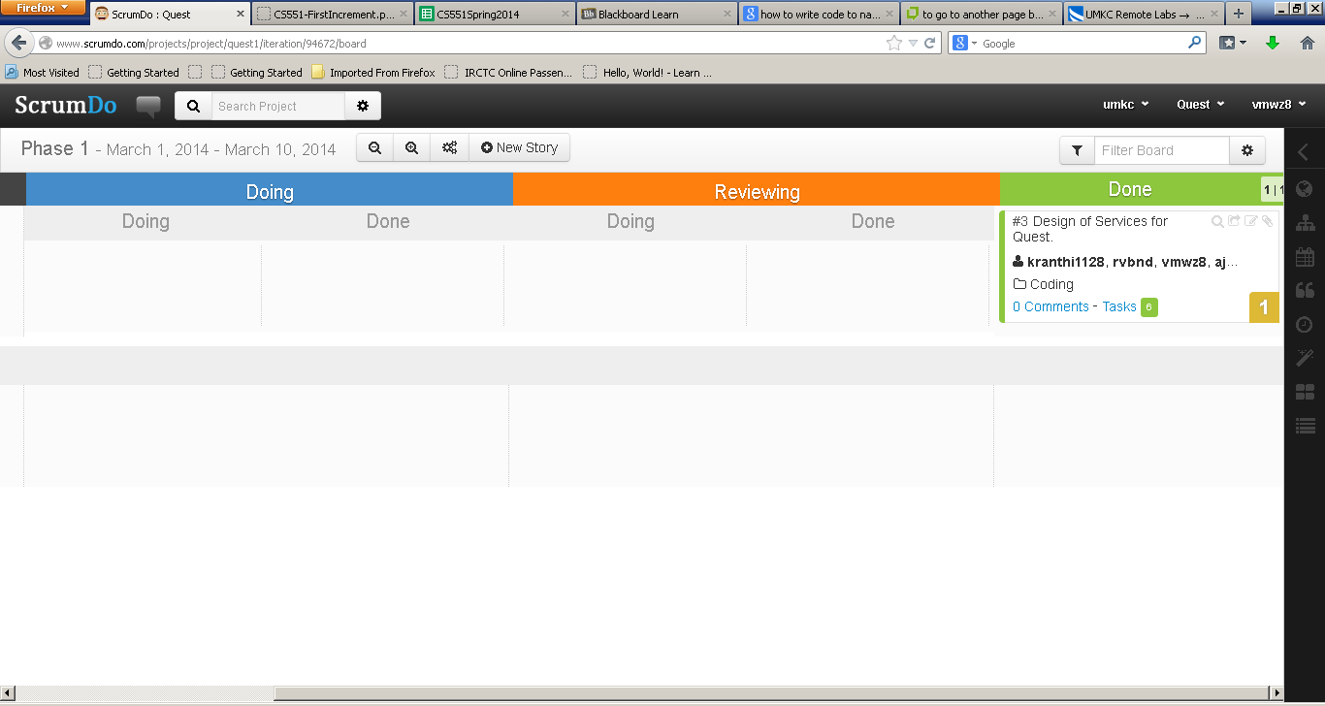

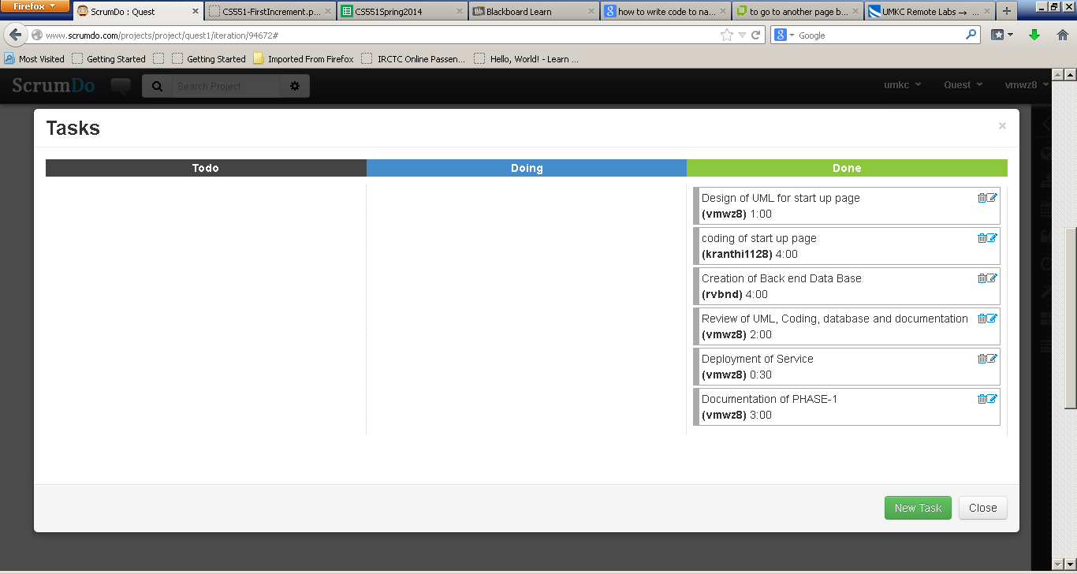

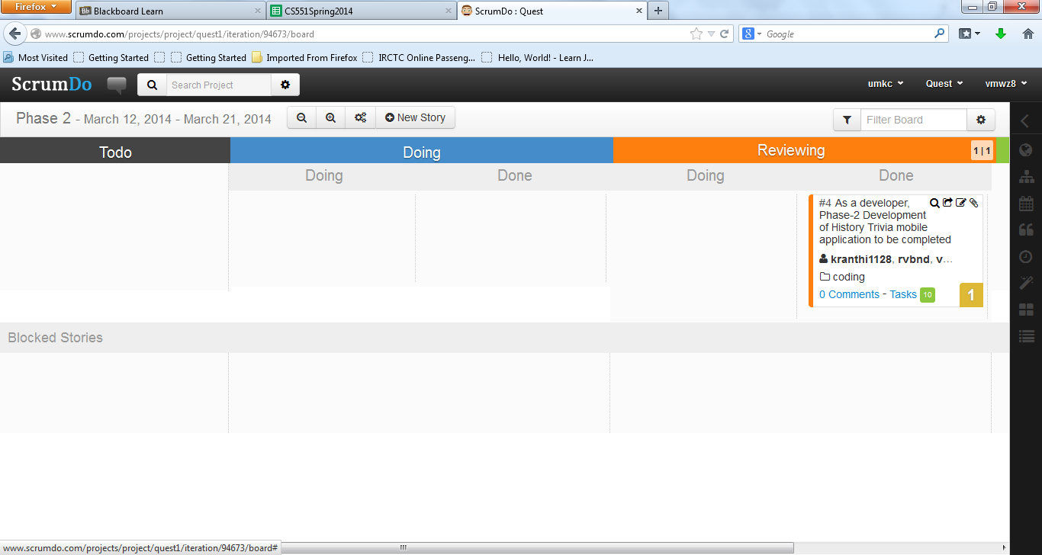

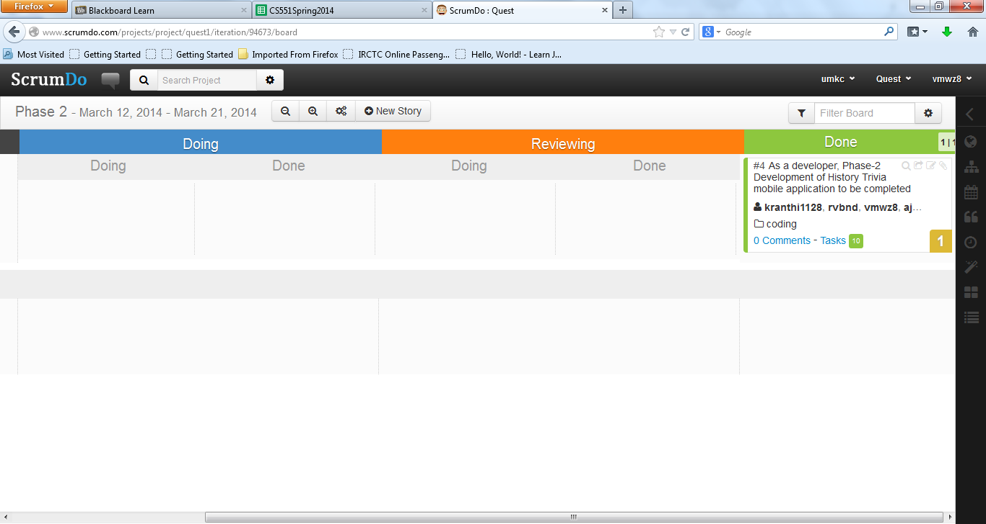

## Technical Tools Used

User Interface (Web Framework)**:**

* HTML
* CSS
* JavaScript

Back End:

* Microsoft Access
* SQL server 2014

Web Services:

* Microsoft Visual Studio 2010 ( C#)
* UMKC Server

UML /Architecture Diagrams**:**

* Microsoft Visio 2013
* Visual Paradigm

## Team Sign OFF

|  |  |  |
| --- | --- | --- |
| Vijaya Vamsikrishna Marrisetty | MVVK | 03/21/2014 |
| Print First and Last Name | Signature | Date |
| Rakesh Videm | RV | 03/21/2014 |
| Print First and Last Name | Signature | Date |
| Venkat Kranthi Reddy Madhire | KR | 03/21/2014 |
| Print First and Last Name | Signature | Date |
| Ajay Kumar Reddy Addula | AKR | 03/21/2014 |
| Print First and Last Name | Signature | Date |